El Paso Holocaust Museum & Study Center’s

2016 Educators’ Conference

November 1 - 2, 2016

Registration Form

Registration Deadline:
October 27, 2016
Name: Address: City: State: Zip:

Phone:

E-Mail Address:

School

Name of School:

District:

Grade Level: Campus Principal:

School Address:

City: State: Zip:

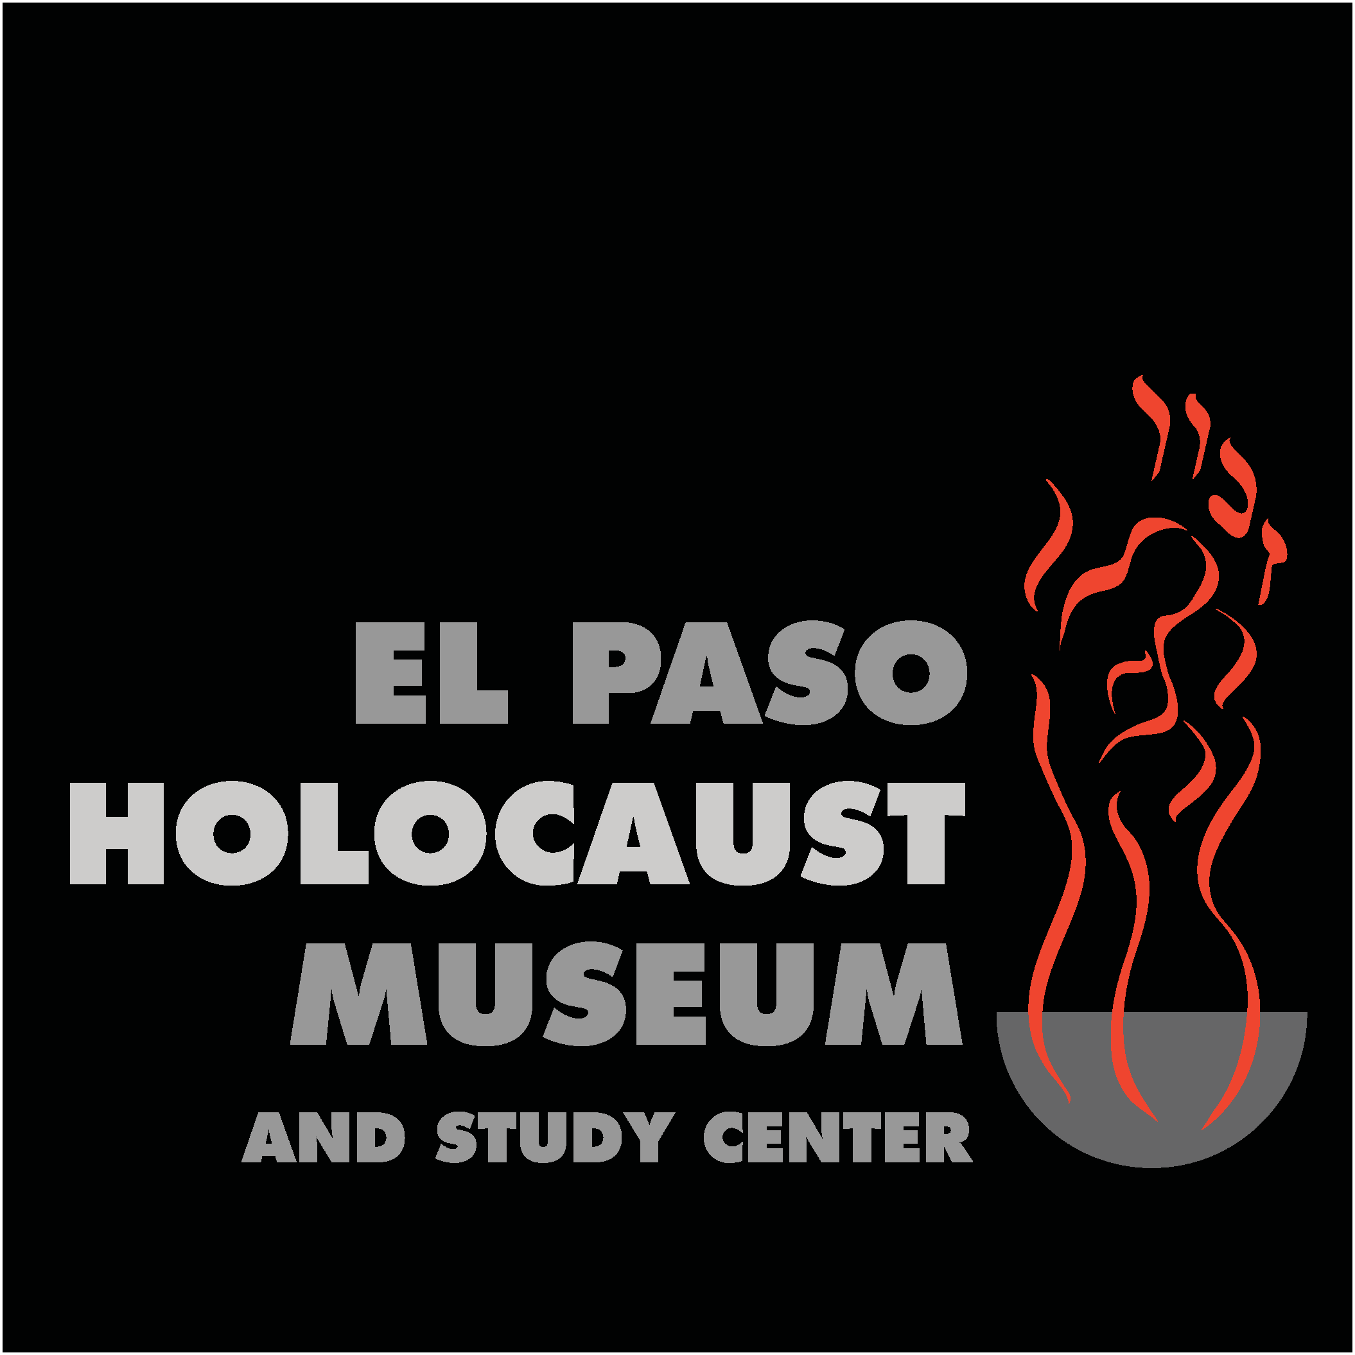

Cost: $95.00 Payment:

Please Note: Registration fees are non-refundable

Scholarship Recipient? :

Party Responsible for Payment: Self School (Purchase Order) Method of Payment: Check Credit Card
Credit Card Information: Visa MC AMEX Discover Card Number: Exp. Date: Cardholder’s Name:
Address: City: State: Zip:

Note: Payment covers meals; curriculum guide; classroom materials & resources

Please mail/fax/e-mail forms to: Jamie Flores, Programming & Education Director
El Paso Holocaust Museum and Study Center
715 N. Oregon, El Paso, TX 79902
P. 915.351.0048 x 28
F. 915.351.0908
jamie@elpasoholocaustmuseum.org

Or register online: www.elpasoholocaustmuseum.org

